Question Bank

Classification of modulation

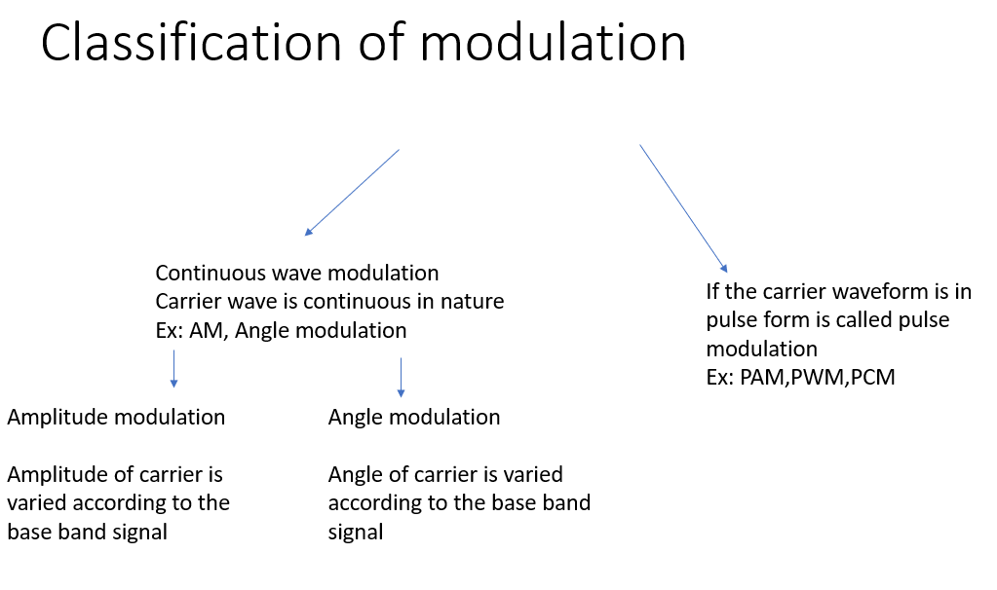

Limitation of AM

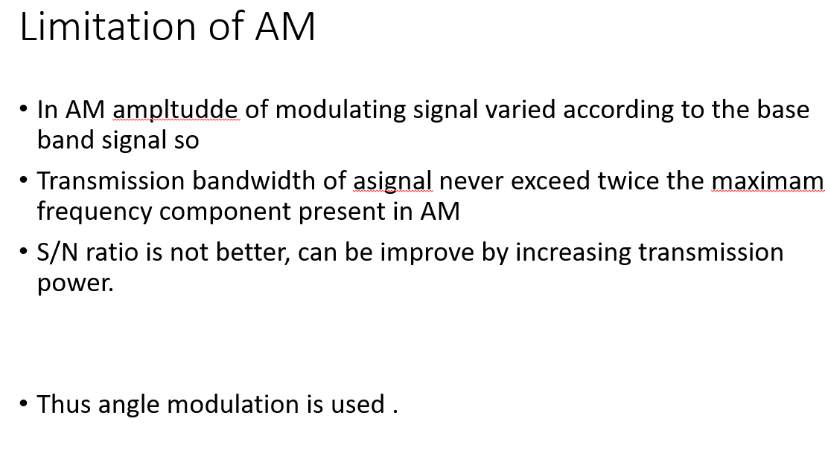

Angle Modulation

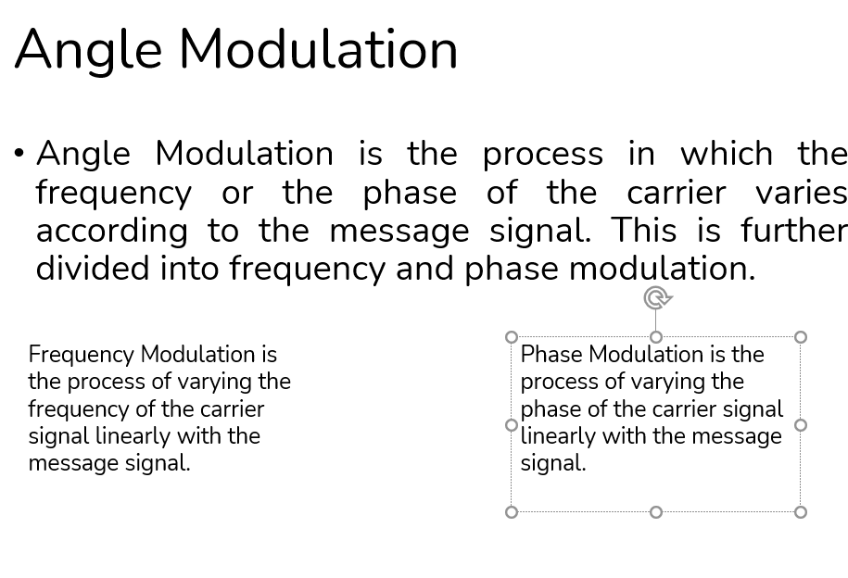

Frequency Modulation

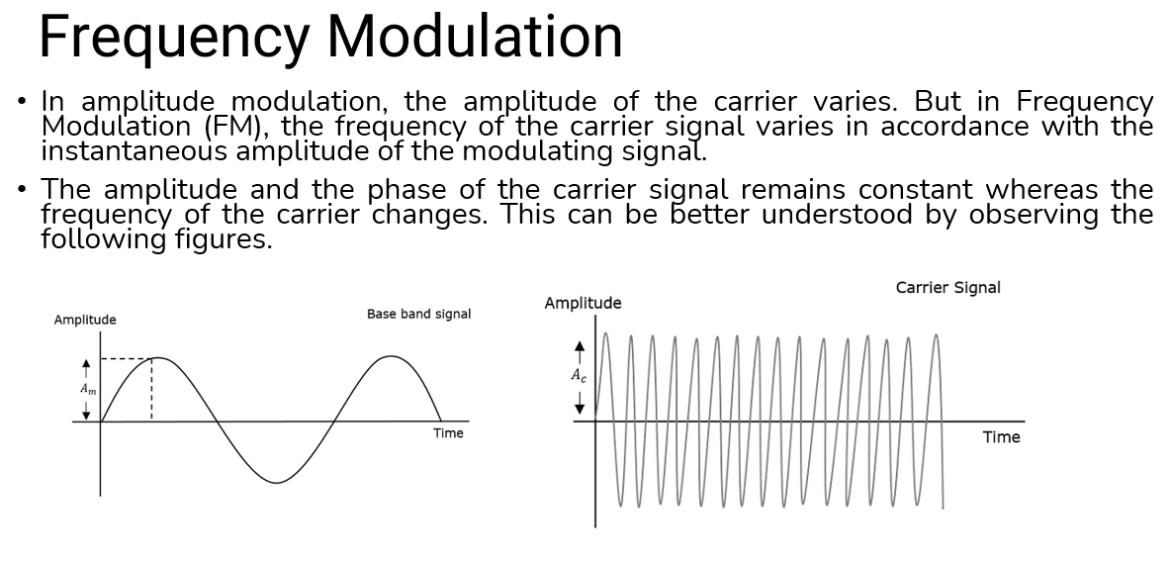

Frequency deviation

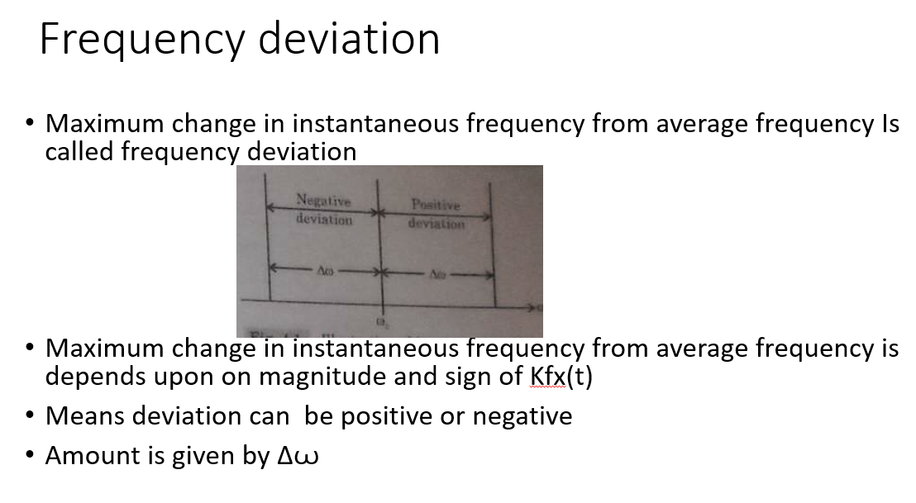

Difference between PM and FM

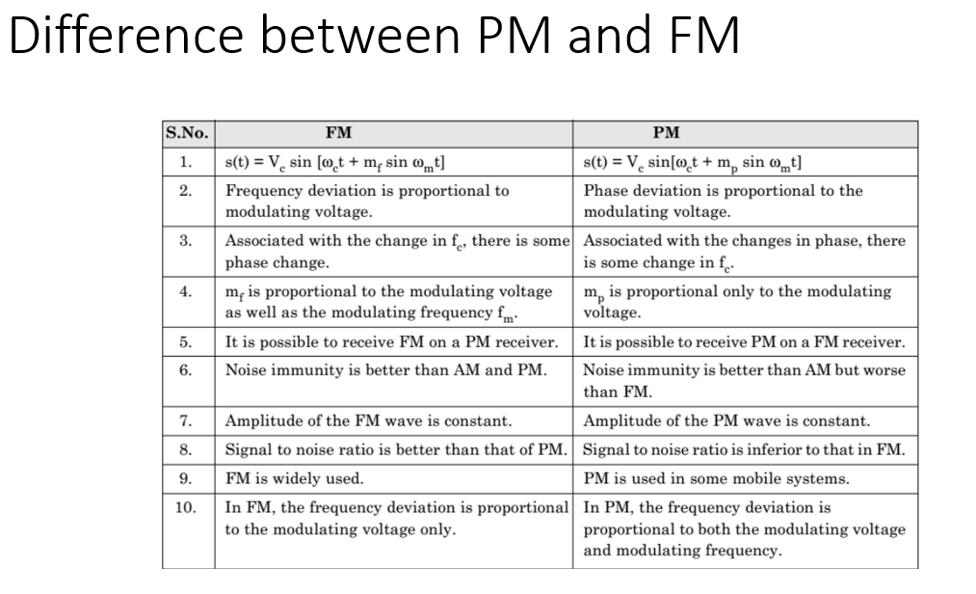

Narrowband FM

* The features of Narrowband FM are as follows −
* This frequency modulation has a small bandwidth.
* The modulation index is small.
* Its spectrum consists of carrier, USB, and LSB.
* This is used in mobile communications such as police wireless, ambulances, taxicabs, etc.

Wideband FM

* The features of Wideband FM are as follows −
* This frequency modulation has infinite bandwidth.
* The modulation index is large, i.e., higher than **1**.
* Its spectrum consists of a carrier and infinite number of sidebands, which are located around it.
* This is used in entertainment broadcasting applications such as FM radio, TV, etc.

Linear and non Linear modulation

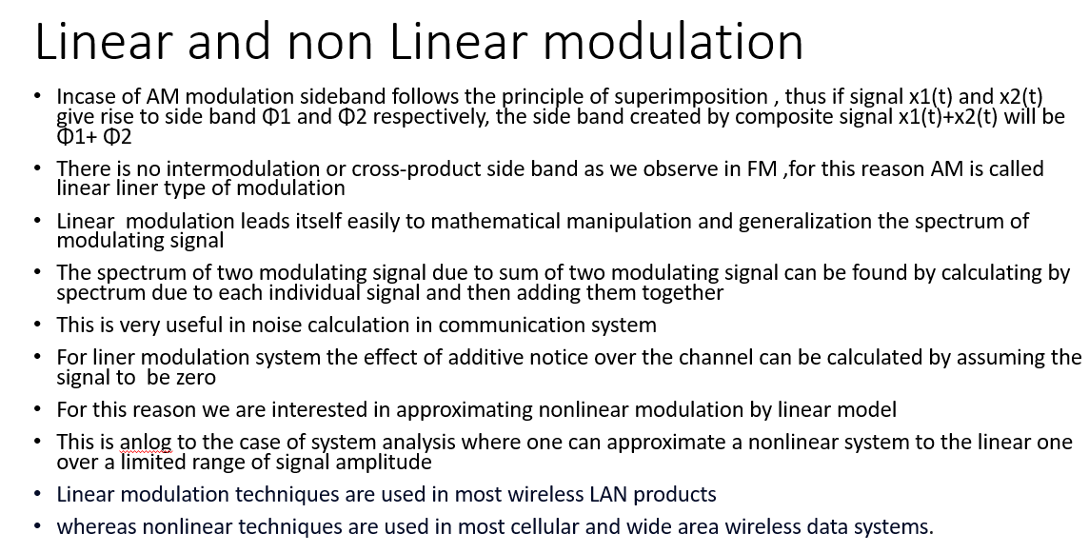

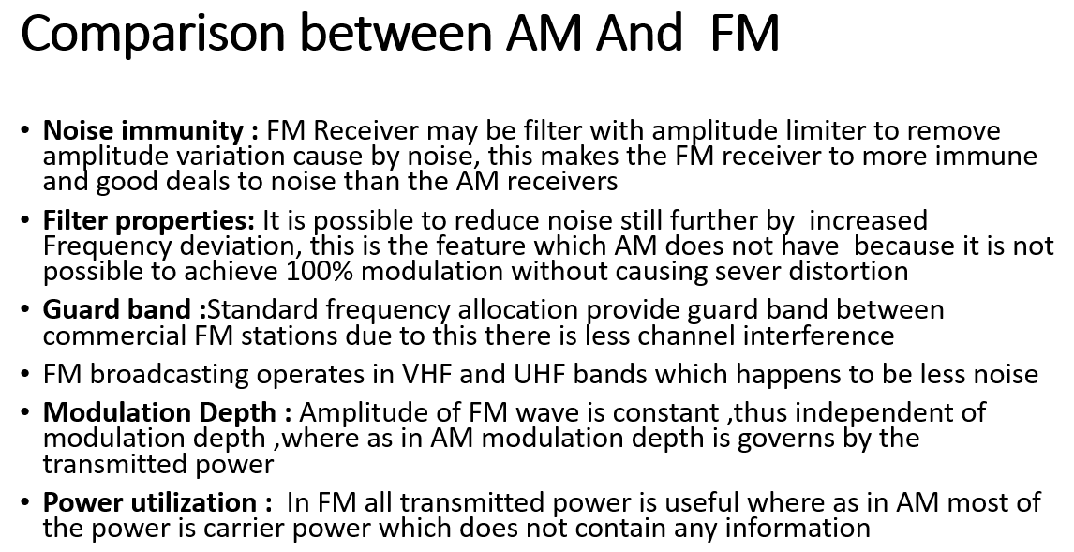

**Disadvantage of FM over AM**

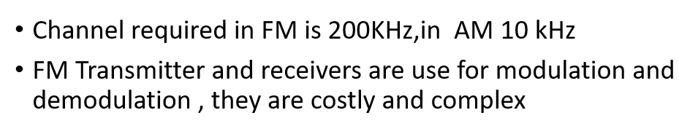

FM Generation

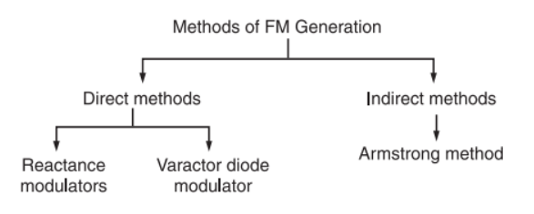

**Direct method Or Parameter variation method**

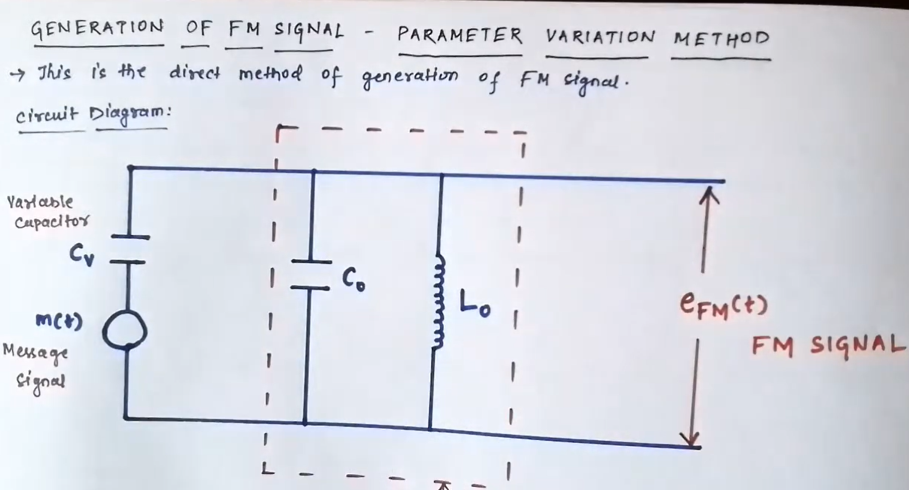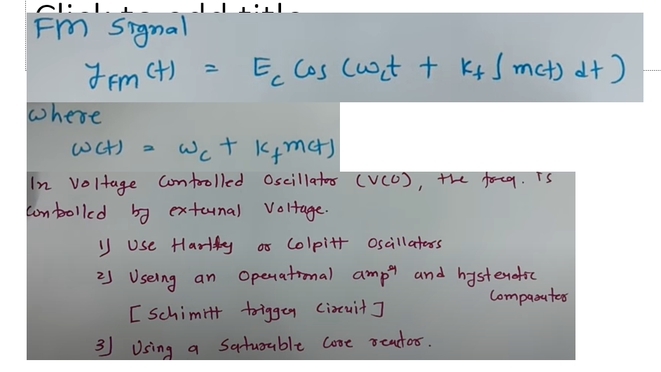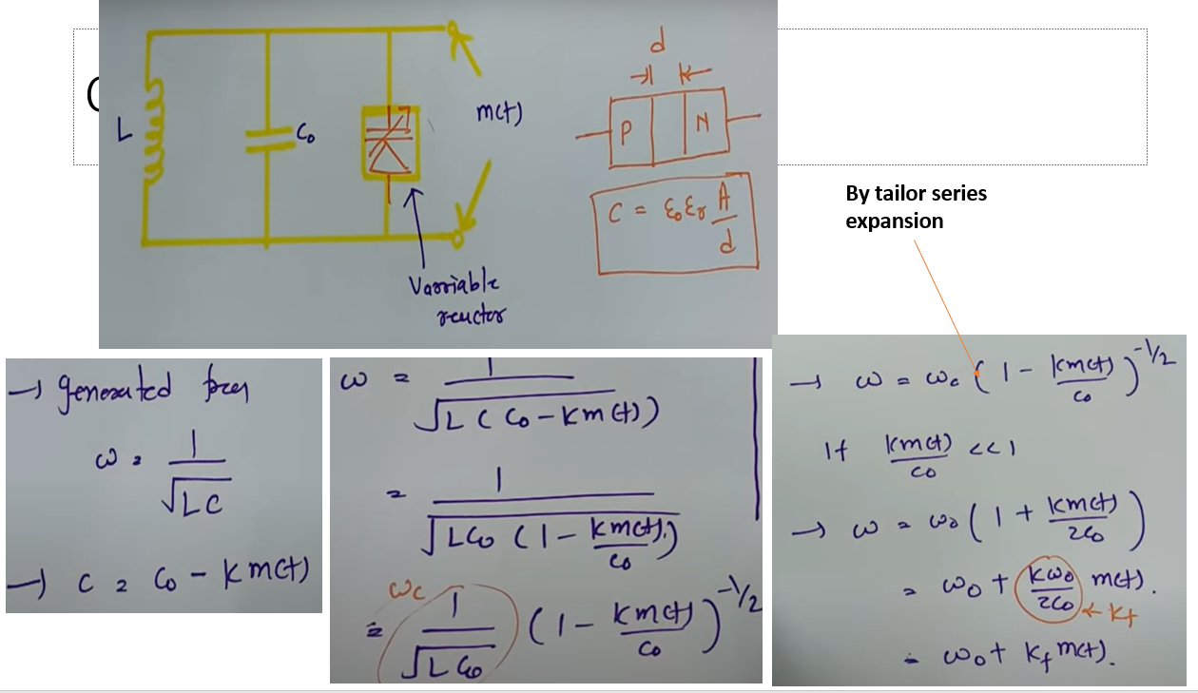

Base band signal directly modulate the carrier

Carrier signal is generate with the help of oscillator circuit This osicalltor circuit uses a parallel Lc tune circuit

The frequency of carrier signal is govern by the expression

Now, we can make the carrier frequency ωc to vary in accordance with the baseband or modulating signal x(t) if L or C is varied according to x(t).

An oscillator circuit whose frequency is controlled by a modulating voltage is called **voltage controlled oscillator** **(VCO)**.

The frequency of VCO is varied according to the modulating signal simply by putting a shunt voltage variable capacitor with its tuned circuit

This voltage variable capacitor is called **varactor** or **varicap.**

This type of property is exhibited by reverse biased semiconductor diodes. Also the capacitance of bipolar junction transistors (BJT) and field-effect transistors (FET) is varied by the Miller-effect. This miller capacitance may be utilized for frequency modulation. In addition to this, the electron tubes may also provide variable reactance (either it is inductive or capacitive) which is proportional to modulating or baseband signal. This type of tubes are called reactance tubes and may be used for FM generation.

The inductance L of the tuned circuit may also be varied in accordance with the baseband or modulating signal x(t).

The FM circuit using such inductors is called **saturable reactor modulator**.

Frequency modulation can also be achieved from voltage controlled devices such as P**IN diode, Klystron oscillators**and**multivibrators.**

**Reactance Modulator**

* 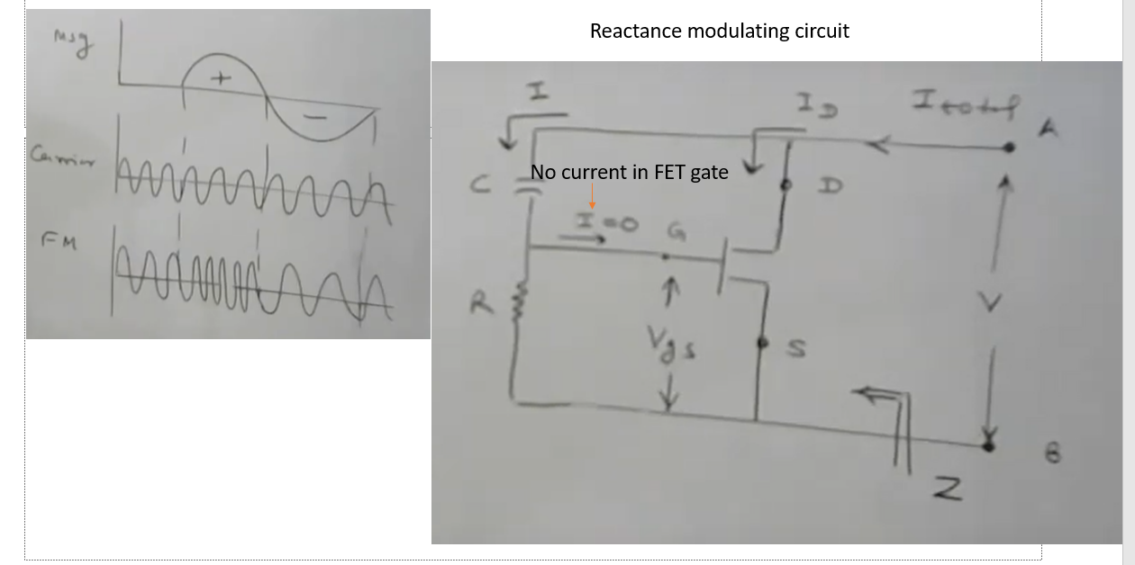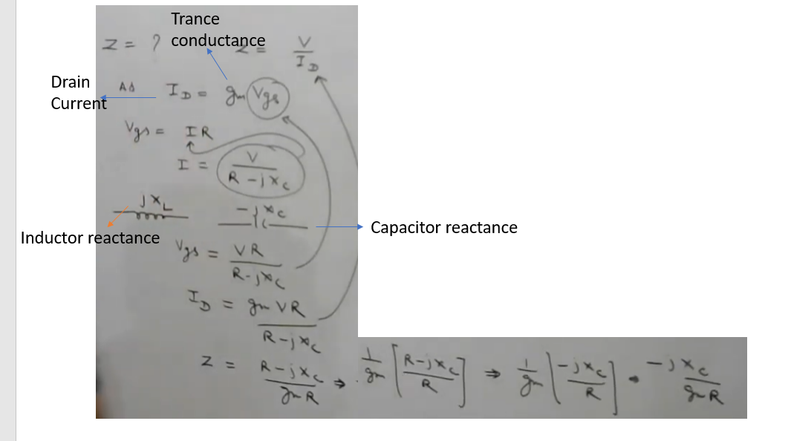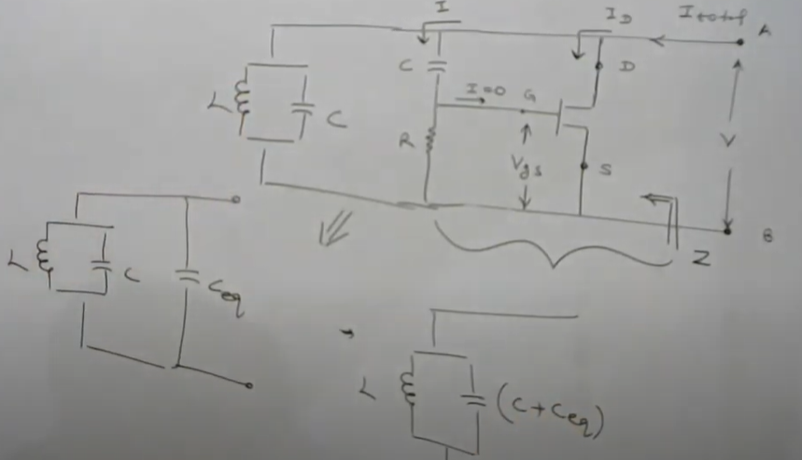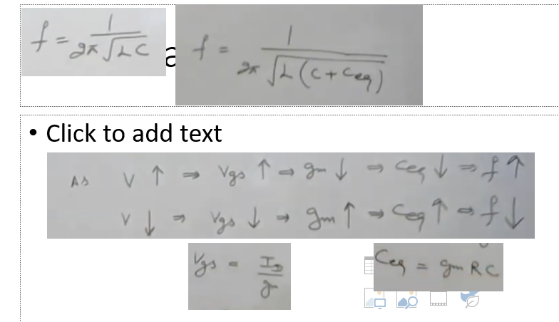

Varactor diode for FM Generation

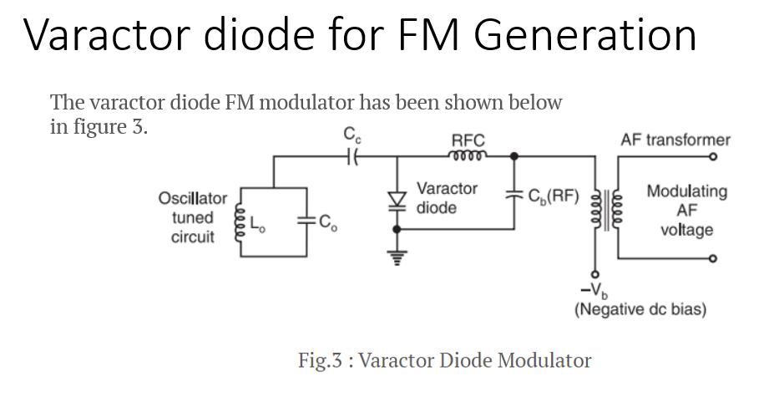

**Working Operation**

The varactor diode is reverse biased by the negative dc source  –Vb.

The modulating AF voltage appears in series with the negative supply voltage. Hence, the voltage applied across the varactor diode varies in proportion with the modulating voltage.

This will vary the junction capacitance of the varactor diode.

The varactor diode appears in parallel with the oscillator tuned circuit.

Hence the oscillator frequency will change with change in varactor dioide capacitance and FM wave is produced.

The RFC will connect the dc and modulating signal to the varactor diode but it offers a very high impedance at high oscillator frequency. Therefore, the oscillator circuit is isolated from the dc bias and modulating signal.

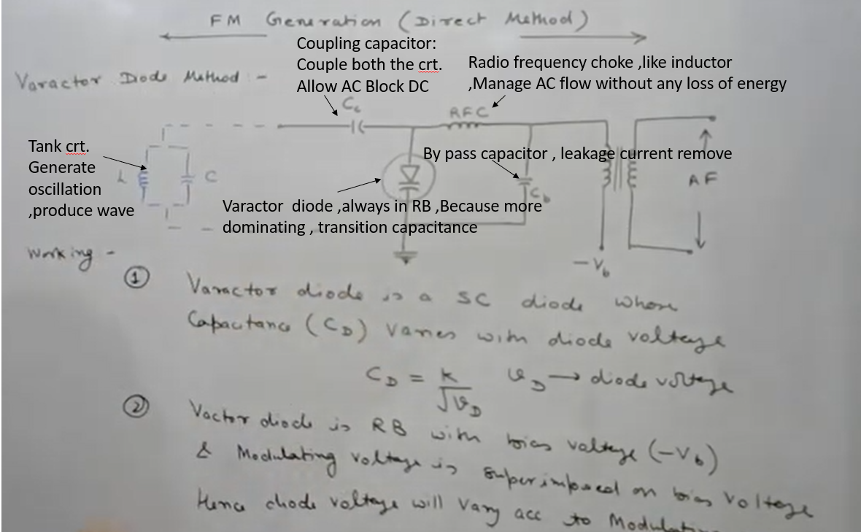

Indirect methord of FM generation

**Drawback of direct method**

Not Stable using Tank crt. Broad casting not possible

Using crystal oscillator instead of LC oscillator

Because Varactor diode is nonlinear so large distortion in direct gen method

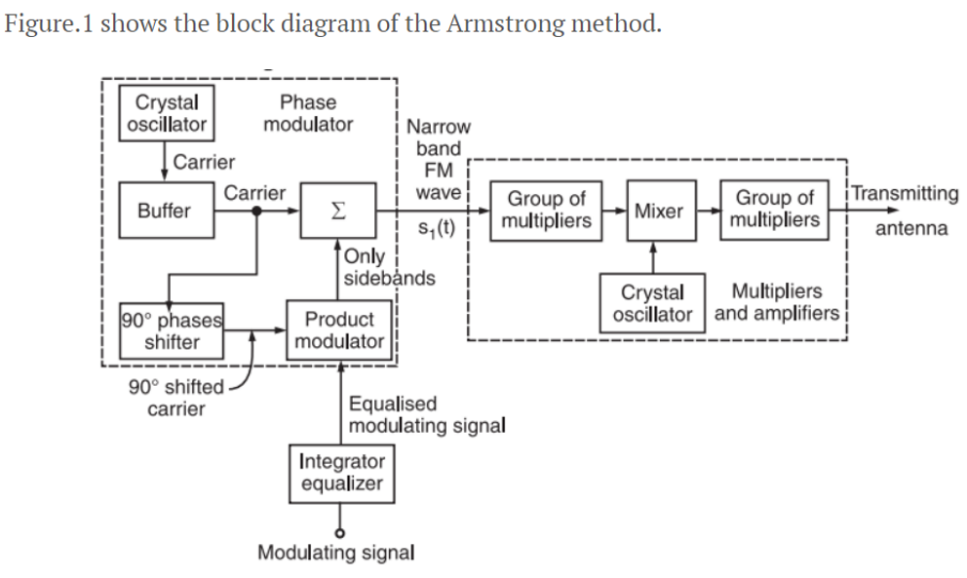

**Working Principle**

The working operation of this system can be divided into two parts as follows:

**Part I: Generate a narrow band FM wave using a phase modulator.**

**Part II: Use the frequency multipliers and mixer to obtain the required values of frequency deviation, carrier and modulation index.**

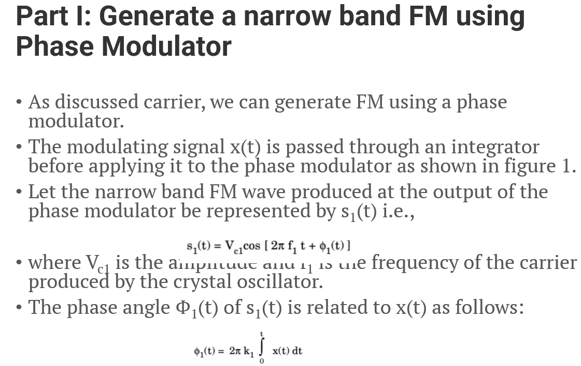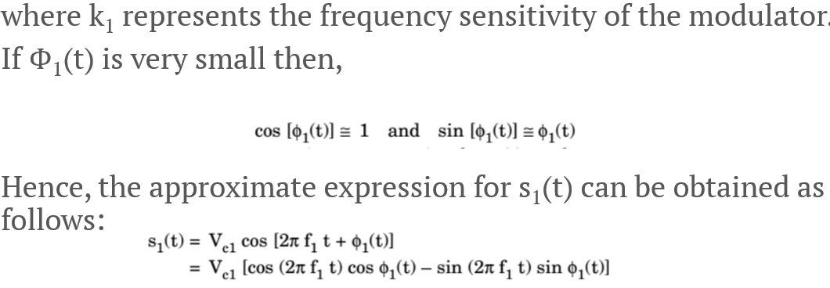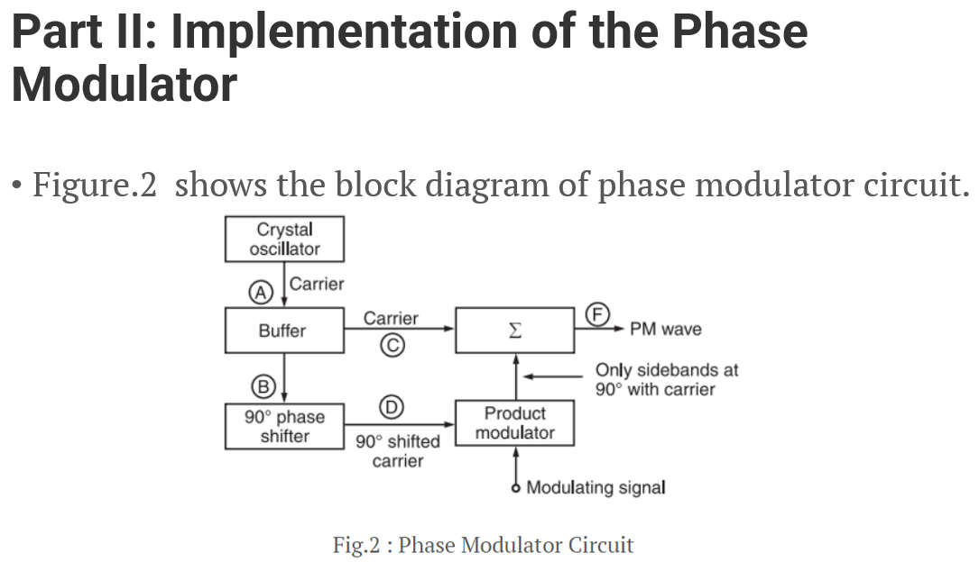

**Working Principle**

The crystal oscillator produces a stable unmodulated carrier which is applied to the 90° phase shifter as well as the combining network through a buffer.

The 90° phase shifter produces a 90° phase shifted carrier. It is applied to the balanced modulator along with the modulating signal.

Thus, the carrier used for modulation is 90° shifted with respect to the original carrier.

At the output of the product modulator, we get DSB SC signal i.e., AM signal without carrier.

This signal consists of only two sidebands with their resultant in phase with the 90° shifted carrier .

The two sidebands and the original carrier without any phase shift are applied to a combining network (∑). At the output of the combining network, we get the resultant of vector addition of the carrier and two sidebands as shown in figure 2.

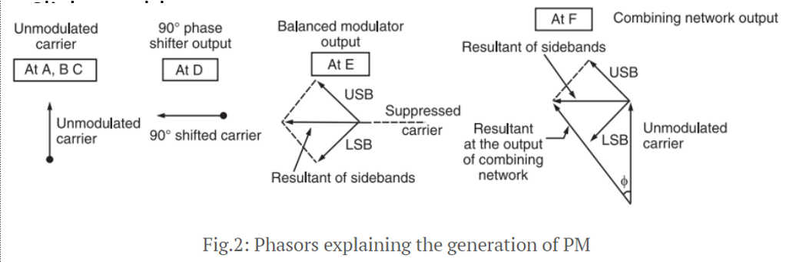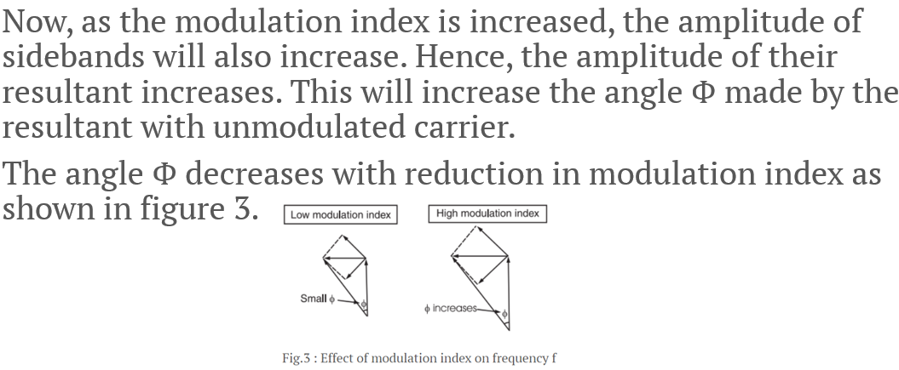

**Part III: Use of Frequency Multipliers Mixer and Amplifier**

* The FM signal produced at the output of phase modulator has a low carrier frequency and low modulation index. They are increased to an adequately high value with the help of frequency multipliers and mixer.

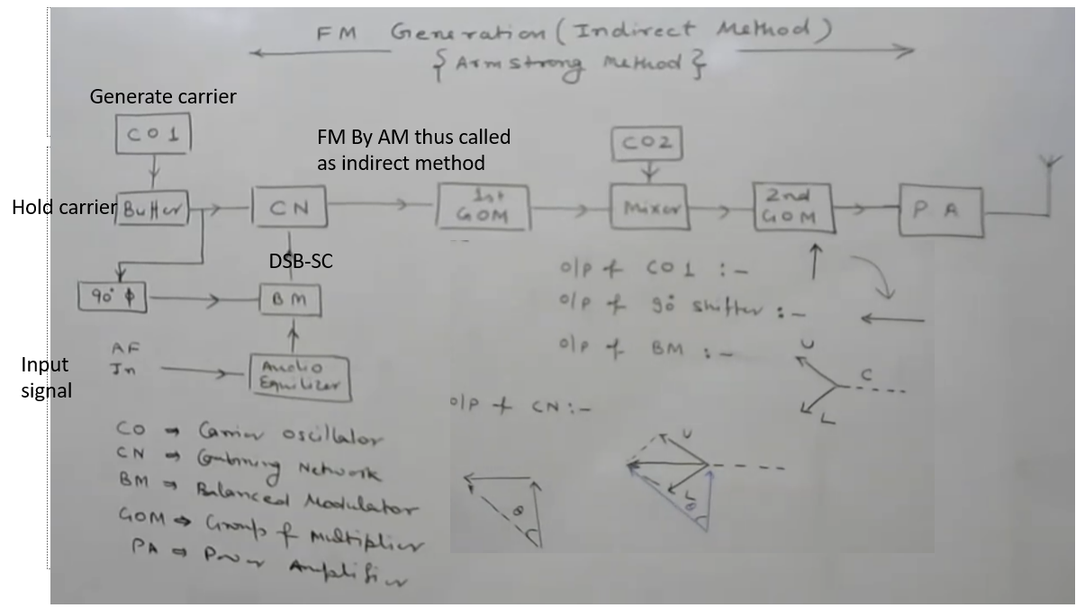

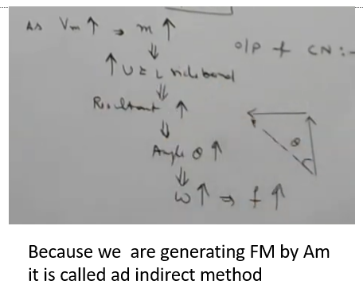

Module 4

Tuned radio frequency receiverTRF is a type of radio receiver that is controlled by one or more RF amplifier stages followed by a detector circuit to extract the audio signal and usually an audio frequency amplifier.

Early models could be uninteresting to operate because when tuning in a station each stage had to be individually adjusted to the station’s frequency.

But now latest models had ganged tuning, the tuning mechanisms of all stages being linked together, and operated by just one control knob.

In the 1930’s it was replaced by the superheterodyne receiver

It consisted of three section RF amplifier, demodulator, and audio amplifier.

The signal received from the antenna is weak and noisy so this signal is given to a broadband RF amplifier.

This RF amplifier enhances the signal-to-noise ratio and amplifies the signal. Then this signal passed through AM detector or demodulator.

The output of AM detector or demodulator is an audio signal. The detected audio signal is then amplified by the audio power amplifier.

The audio amplifier output give to the speaker and then it finally produces the sound.

The RF amplifier is tuned to a specific frequency that is to be received. Hence if another frequency is to receive, then another TRF receiver should be used.

By using the RF amplifier tuned to a wide range of frequencies this problem is solved. But this reduces the selectivity of the receiver.

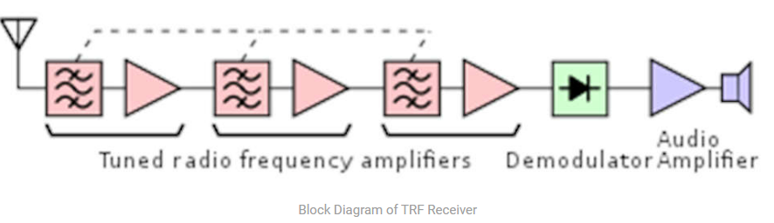

**Advantages of TRF Receiver**

Simplest type of receiver since it does not involve mixing and IF operation.

Very much suitable to receive single frequency.

TRF receivers have good sensitivity.

**Disadvantages of TRF Receiver**

Bandwidth changes with center frequency, when the TRF receiver is used to receive a wide range of frequencies.

Multiple stages of RF amplifiers are used. This can lead to instability since they all are tuned to the same center frequency. Hence stagger tuning is to be used.

The gain of the TRF receiver is not uniform over a wide range of frequencies.

**Application of TRF Receiver**

It was used in the early days of wire-less technology but it is rarely used today as other techniques offering much better performance are available.

**Limitations of TRF Receiver**

It suffers from variations in BW over the tuning range ( s 40 – 1650 kHz).

The gain of TRF RX is not uniform over the tuning range.

The TRF is unstable at high frequency.

Gang tuning of more capacitors simultaneously is difficult.

Due to Rf amplifier oscillate at higher frequency, small portion of output leak back to the input create positive feedback and oscillation, create coupling capacitance In power supply not good for receiver.

Due to enforced used of single tuned crt. Selectivity is poor

Bandwidth variation over higher range

Superheterodyne Receiver

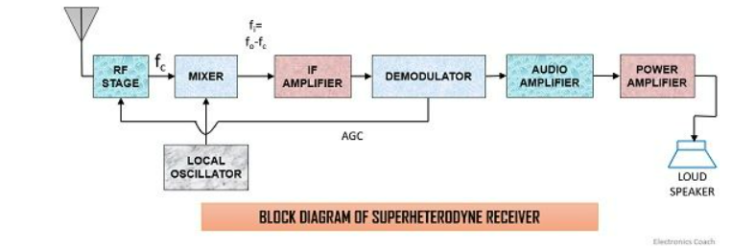

**Definition**: Superheterodyne receiver works on the principle of heterodyning which simply means **mixing.** It is a type of receiver which mixes the received signal frequency with the frequency of the signal generated by a local oscillator.

The output of mixer provides a lower fixed frequency also known as**intermediate frequency**. These receivers are called Superheterodyne receivers as the frequency of the signal generated by the local oscillator is more than the frequency of the received signal.

Working of Superheterodyne Receiver

**receiving antenna**: The receiving antenna receives the signal which was sent by the transmitter. It sends the received signal for further processing.

**RF amplifier**: The received signal is fed to the RF amplifier stage so as to amplify it, as the signal gets attenuated during long-distance transmission. It is tuned in such a way that it can choose the desired carrier frequency and amplify it.

**Local Oscillator**: This circuit basically generates a signal with a fixed frequency and the output is then fed to the mixer. When we talk about **AM broadcast** system, the intermediate frequency is **455 KHz** that simply means that local oscillator should select such a frequency which is 455 KHz above the incoming signal frequency.

**Mixer**: A mixer simply mixes the carrier frequency with the frequency of the signal generated by the local oscillator.

Here, two different frequencies are to be mixed so as to have another frequency component of lower value. Now the thing that first comes to our mind is why the mixer produces a lower frequency value, which is the difference between the two frequencies. The summation of the carrier and local oscillator frequency at the output of the mixer will give rise to image frequency which is treated as a type of noise or distortion in the signal. This is the reason why the mixer generates a frequency difference at its output. This difference frequency is a constant value irrespective of the variations in the input, known as the **intermediate frequency.**



The constant frequency at its output is gained by **capacitance tuning**. In capacitance tuning, several capacitances are arranged together and operated by a controlling knob.It doesn’t matter what the incoming signal frequency is, the RF amplifier and local oscillator must be tuned to it.

**IF amplifie**r: This section basically amplifies the output of the mixer. IF amplifier provides sensitivity(gain) and selectivity (bandwidth requirement) to the receiver. As it consists of several transformers consisting of pairs of the tuned circuit.Here, the sensitivity and selectivity are uniform and does not show variations as in case of TRF receivers because **IF amplifier’s characteristics are independent of that of the received signal frequency** as it works on the intermediate frequency.  
  
Due to this, the system design is quite easy so as to provide constant bandwidth along with high gain.This section has narrow bandwidth and due to its lower bandwidth, it rejects all other frequency so as to reduce the risk generated from interference.The lower bandwidth accepting nature supports Superheterodyne receivers to give much better performance than other types of receivers.

**Demodulato**r: Demodulator is placed exactly after the IF amplifier so that the constant frequency signal is demodulated and the message signal can be extracted from it.

**Audio amplifie**r: The original signal is fed to the audio amplifier which does not hold distortion or noise so that it can amplify audio signal to a particular level.

**Power amplifier**: Here, the signal is further amplified to a particular power level which can activate the loudspeaker. The amplified signal is finally fed to the loudspeaker circuit which converts the electrical form of the signal into an audio sound signal which can be heard by the listeners.

**Receivers characteristics:**

**Sensitivity**: In most simple words we can say it is the ability to amplify a weak or low signal. 150µV is the typical sensitivity value for small broadcast and 1µV or below is for high-quality communication.

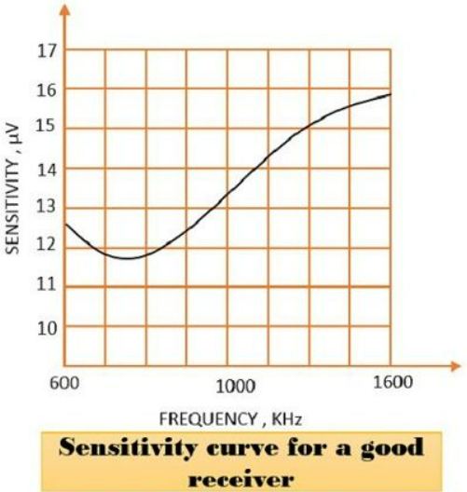

**Following factors determines the sensitivity of Superheterodyne receiver**:

1. The gain of RF amplifier
2. The gain of IF amplifier
3. Noise factor of receiver

**Selectivity**: It is the ability of any system that decides whether the signal is desired or undesired. At high-frequency selectivity is poor, better selectivity is achieved at low frequency.

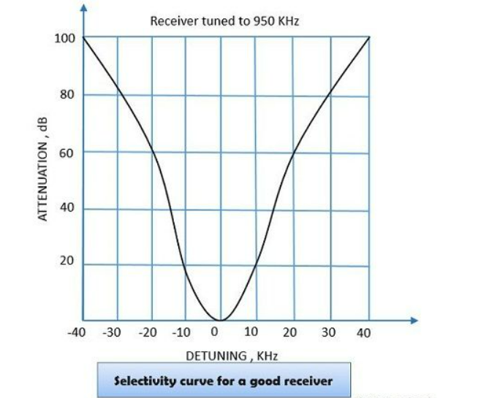

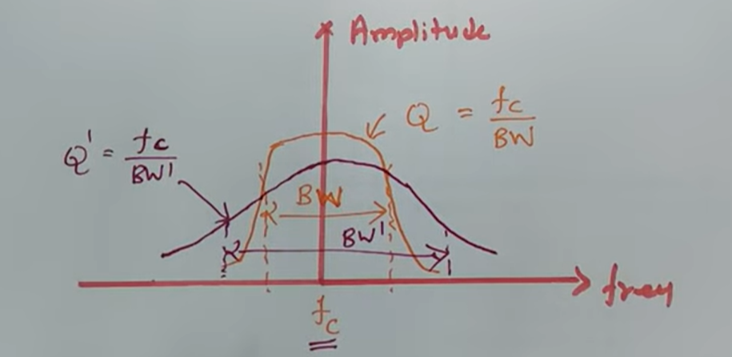

**Fidelity**: It is the system’s ability to produce an original signal without distortion. It is essential to produce a good quality signal. It ensures that the reproduced signal must be an exact copy of the original signal.

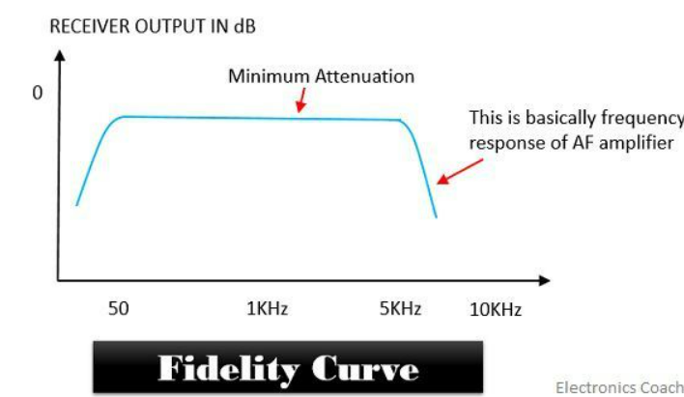

1. **Advantages**:
2. It operates at low signal level.
3. The mixer provides fixed frequency operations.
4. Provides excellent selectivity and sensitivity.
5. **Disadvantage**:
6. Overall system cost is increased as additional circuits are used.
7. **Applications**:
8. Superheterodyne receivers find its use in various places as in Television, Radio receiver, commercial radios

Double spotting

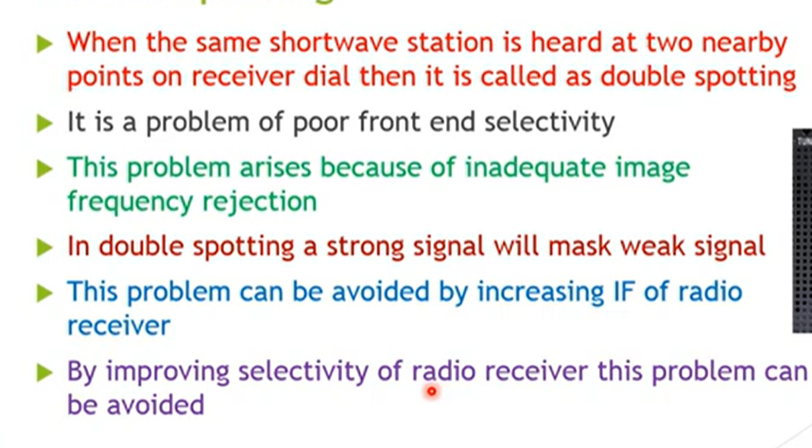

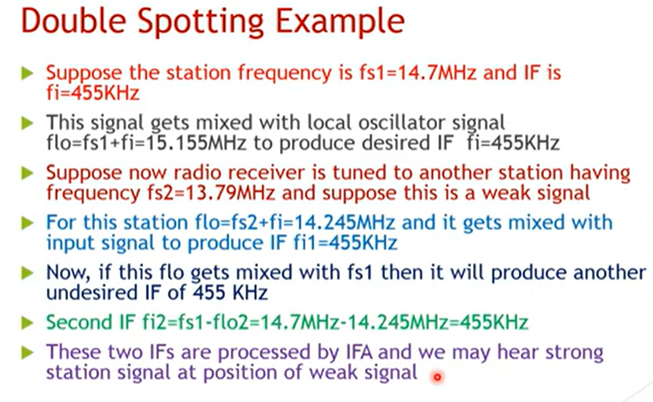

Image rejection ratio

